Scott Foley 1/7/2016

Module 1 – Activity

Module 1 – plan for application of MARFOL solutions and Diagnostics

Front pager of application

* Name of application MARFOL
* My name Scott Foley is in the username slot, from this mock front page the user can sign in
* From there the user will be navigated to the main menu where the user can have a variety of choices on the buttons to choose from.
* The purpose of this application is to help people find out what is wrong with their car before they get to the auto shop with this app through a scanner.
* The target audience will be everyone personal automotive transportation there is not one specific audience
* The application would free for the service of use and but add on will have a charge
* In terms of the file size, around 45 MB would be what I am shooting for in this application
* There will be animations but no sounds or music, there will be animation when transitioning pages from the home page to the scanner page and so on
* some photos would need to be found, photos of vehicles so the application centers around the automotive theme
* To develop this application it would take about 6 months because of all the features within this app
* How this application works is displayed below

THE MAIN PAGE OF APPLICATION

* This page allows the user to sign in and or sign up for an account, once the account is created then it will take you to the account page

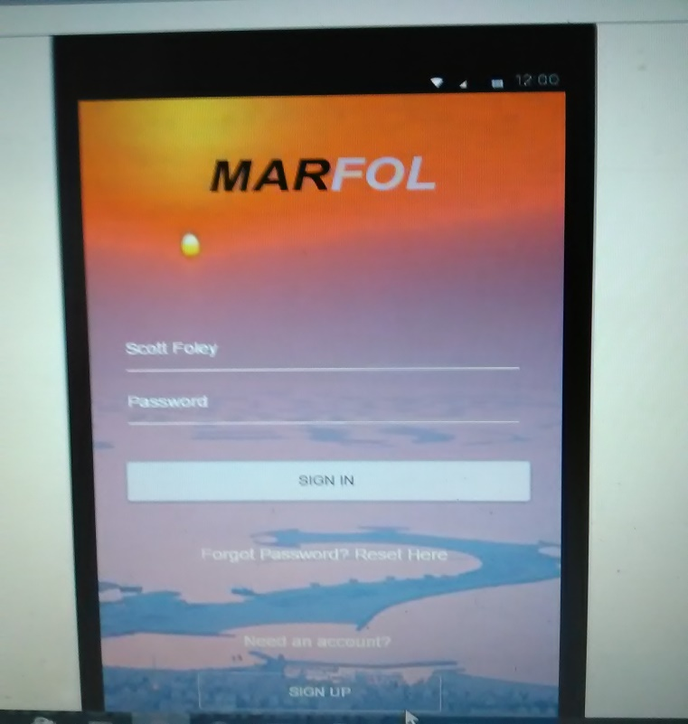

NEXT SCREEN

* Is the registration page, this page has the user sign in with their name, email, vin number of the car/truck and phone number, username and password

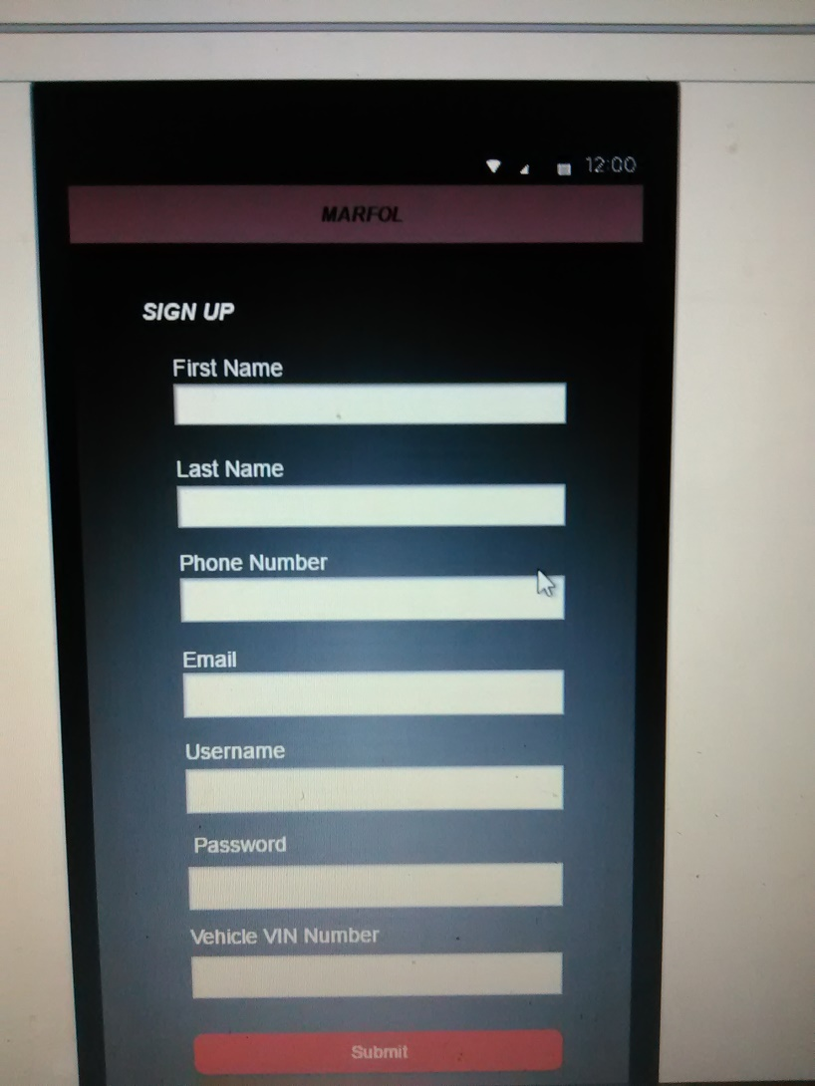

* My Account (this is the first thing that the user registers into. The my account requires users to registered their vehicle VIN number , make ,model and year of the vehicle
* Scanner (The user can tap this button and pull up the scanner for the vehicle) once the user holds their cell phone up to the car and once the scanner is completely still on the car then scan will take place with a line that moves across the car to detect if there are problems with the vehicle
* Once the scan is complete the recommendations button under the scanner will allow the user to take the next step to take care of the repair.
* There will be video tutorials on how to use the scanner and navigate through the application (Tutorials button)
* A list of nearby automotive shops that can repair, next to the address of the automotive companies is a map of where you can find the address, from there the user picks where they want to go and then will have the chance to send the report of the car trouble to the company via email (Scanner button-once scan is competed)
* Saved recommendations will be another button that I will use in the future so that users can go back and access their results with the touch of a button

From there the car can be either toughed or driven if safe to the auto shop(We made it to the shop!)